

NAN HUA PRIMARY SCHOOL _  
2019 PRELIMINARY EXAMINATION  
PRIMARY 6

ENGLISH LANGUAGE

BOOKLET A

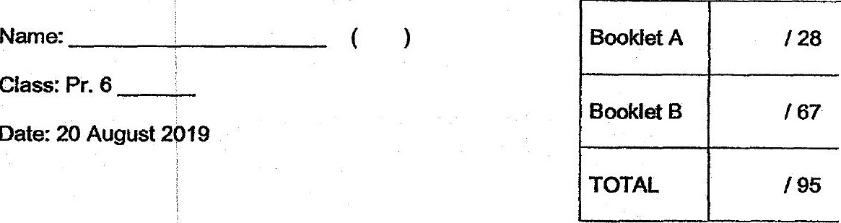

Ciass: Pr. 6 _________.

Date: 20 August 2019

Parent's Signature & Date

Tota] Time for Booklets A and B: 1 hour 50 minutes

INSTRUCTIONS TO CANDIDATES

4. Bo not turn over this page unti! you are told to do so.

2. Follow all instructions carefully.

3. Answer ail questions.

A. For Booklet A, shade your answers on the Optical Answer Sheet (OAS)  
provided, .